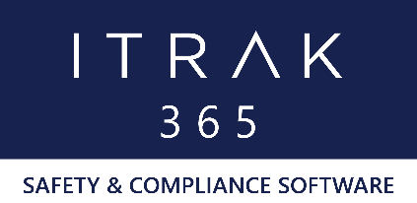

ITRAK 365 by NeoSystems

Quality, Health & Safety, and Environmental Solution
Supported Mobile Devices (OS)

- Android: Devices running Android 6.0 to 9.0

- Apple (iOS):
iPhone 5s
iPhone SE
iPhone 6, 6 Plus
iPhone 6s, 6s Plus
iPhone 7, 7 Plus
iPhone 8, 8 Plus
iPhone X, iPhone XS/XS Max/XR
iPad Air
iPad Air 2
iPad Mini 2, 3, 4
iPad Pro (all)

- Windows 10: Devices running Windows 10

