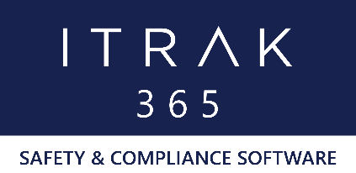

ITRAK 365 by NeoSystems

Quality, Health & Safety, and Environmental Solution
List of LAUNCH Supported Forms

- Date: February 2020

- Forms:
- Community Interaction
- Complaint Form
- Confidential Form
- Inspection Template
- Incident Report Form
    - Field Level Risk/Hazard Assessment
- Office Inspection

